A MINI PROJECT ON

# SMART LINKEDIN BOT

Report Submitted in

Partial Fulfillment of the Requirements

For the award of Degree of

# BACHELOR OF TECHNOLOGY

(Department of Computer Science and Engineering)

To

**Dr. A.P.J. ABDUL KALAM TECHNICAL UNIVERSITY**,

**LUCKNOW**



**SUBMITTED BY:**

**DARAKHSHA RAYEN (2001870100042)**

Under the Supervision of

**Mr. Ashutosh Mishra**

DEPARTMENT OF COMPUTER SCIENCE AND ENGINEERING.

FEROZE GANDHI INSTITUTE OF ENGINEERING AND TECHNOLOGY

1.

## 

## Declaration

**I hereby declare that this submission is my own work and that to the best of our knowledge and belief , it contains no material previously published or written by another person nor material which to substantial extent has been accepted for the award of any other degree or diploma of the university or other institute of higher learning ,except where due acknowledgement has been made in the text.**

**Date: 01/12/2022 Teacher’s Signature:**

**Name**

**DARAKHSHA RAYEN (2001870100042)**

**Computer Science & Engineering**

2.

**DIVISION OF COMPUTER ENGINEERING**

**FEROZE GANDHI INSTITUTE OF**

**ENGINEERING AND TECHNOLOGY,**

**RAEBARELI**

**CERTIFICATE**

Certified that this is a bonafide record of the mini project report entitled

“SMART LINKEDIN BOT”

Is done “DARAKHSHA RAYEN” of the Vth semester, Roll No.(2001870100042) Computer Science and Engineering in the year 2022 in partial fulfillment of the requirements to the award of Degree of Bachelor of Technology in Computer Science and Engineering of Feroze Gandhi Institute of Engineering and Technology.

ASHUTOSH MISHRA Dr. SUNIL VERMA

**SEMINAR GUIDE HEAD OF DEPARTMENT**

Lecturer

Computer Science and Engineering Computer Science and Engineering

FGIET FGIET

3.

**ACKNOWLEDGEMENT**

We would like to express my deep gratitude towards my internal guide t **Asst. Prof. Mr. Ashutosh Mishra**, Department of CSE for his support in the completion of my dissertation. By providing the google and reference materials for the moral support extended to me. I wish to express my sincere thanks to **Dr.** **Sunil Verma HOD, Dept. of CSE** for his unconditional help and inspiration.

**Date : 01/12/2022 Teacher’s Signature**

**Name**

**DARAKHSHA RAYEN (200180100042)**

4.

**ABSTRACT**

Linkedin data and connections are useful for people and students nowadays. innovation, entrepreneurship and technology are all the professional things there.

LinkedIn isn’t just for job hunters and entrepreneurs. Sure, millions of people use LinkedIn every day to expand their connections and careers, but you can also use it to expand your business.

Linkedin Smart Bot grab all these data and people can use these data for their profits

This social networking tool exposes you and your company to millions of connections, which you can utilise to create relationships with people and other businesses in order to improve your brand. LinkedIn is primarily a professional social network. It’s all about professional development, networking, industry conversations, and other business-related events. LinkedIn is a great place to locate customers, employees, and partners. LinkedIn data is also highly used across many business operations. So we explore some steps you can do to make complete use of your LinkedIn data

Bot will replace with human and save their time according to need automation process

has been defined and people can do other imp work on that time .

we have the career and job related lot of data which to student can start career by getting Job , Mentorship, professionally updated and people can do freelancing from their connection get positive recommendation

5

### **TABLE OF CONTENTS**

**CHAPTER NO. SMART LINKEDIN BOT PAGE NO.**

**DECLARATION**

**CERTIFICATE**

**ACKNOWLEDGEMENT**

**ABSTRACT ii**

1. DECLARATION 2

2. CERTIFICATE 3

3. ACKNOWLEDGEMENT 4

4. ABSTRACT 5

5. INTRODUCTION 7

6. WHY LINKEDIN AUTOMATION 8

7. LINKEDIN SOFTWARE TESTING 9

8. SELENIUM TESTING WITH PYTHON 10

9. SETTING UP THE TEST ENVIRONMENT 11

10. SMART LINKEDIN BOT SOFTWARE 11

11.ADVANTAGES OF LINKEDIN BOT 12

13.CONCLUSION 13

INTRODUCTION

Humans do daily repetitive tasks and invest a lot of time doing the same work and the quantity of work is low and time taking now student and people have professional career and they want to grow they need to do search daily job and career related query they bored and worry about the career and frustrated from searching daily these data and connecting with people. Automation process can help on these kind of task and Linkedin Smart bot is Automation process of software

**Automation Testing is the method of testing software products with special testing tools and frameworks to minimize human intervention and maximize quality .** When a company develops a product, it is bound to have defects. So, before the release of the product, the company needs to capture the flaws in it to provide a seamless user experience. It is the responsibility of the testing team to perform various kinds of testing, from functional to non-functional, to ensure the effectiveness, efficiency, and better user experience of the overall product.

Linkedin Smart bot is an automation process with python selenium which to linkedin website tasks are fully automated data scraping easily hours work done in min quickly. there is no any need of doing manual work of website

7.

**WHY LINKEDIN AUTOMATION IS USEFUL**

LinkedIn is a great place to locate customers, employees, and partners. LinkedIn data is also highly used across many business operations. So we explore some steps you can do to make complete use of your LinkedIn data.

it’s not about making money, it’s about being visible and valuable. You must educate as well as deliver beneficial knowledge. Brand pages on LinkedIn have become increasingly significant as a method to display your company, the goods, and services you provide, and provide relevant and valuable information to followers. Furthermore, each of your employees’ profiles will include information about where they work. Anyone who connects with your employees’ profiles has the possibility to click on your corporation name and visit the corporate page. This is a terrific approach to broaden the reach of your organization. Running LinkedIn advertising targeted at your LinkedIn group mates is a great and economical approach to grow your company page followers

Monitoring the company pages of your partners, clients, and prospects and connecting with them by commenting, following, and promoting their posts is a terrific method to get your firm on the radar of your prospects.

The automation can save the save the lot of time and collect the quality of data from linkedin process automation can grab data from company employes , from people connection and job post

8.

**LINKEDIN SOFTWARE TESTING**

When a company develops a product, it is bound to have defects. So, before the release of the product, the company needs to capture the flaws in it to provide a seamless user experience. It is the responsibility of the testing team to perform various kinds of testing, from functional to non-functional, to ensure the effectiveness, efficiency, and better user experience of the overall product

In linkedin also have lot functionality those can be automated and no need manual work social media organizer process which to handle social media

### **The Right Automation Tool**

Automation Testing is not possible without the right testing tool. Selecting the right tool is a critical phase in the testing life cycle where one has to consider the following points:

* Familiarity with the tool among the resources on-board
* Total budget and flexibility
* Technologies and programming languages like Python C# used to build the project
* Choosing a tool that has a support team to take care of any queries and issues

**SELENIUM TESTING WITH PYTHON**

Selenium is an open-source and a portable automated software testing tool for testing web applications. It has capabilities to operate across different browsers and operating systems. Selenium is not just a single tool but a set of tools that helps testers to automate web-based applications more efficiently.

Selenium WebDriver is the successor to Selenium RC which sends commands directly to the browser and retrieves results

**Python has a module of selenium**  Webdriver is the parent of all methods and classes used in Selenium Python. It is the driving force of Selenium that allows us to perform various operations on multiple elements on a webpage. Driver has various methods and attributes one can use to automate testing in Python

method example add_cookie, click , back , close etc.

element are the web selector we can use xpath , css selector etc

.

10.

**SETTING UP THE TEST ENVIRONMENT**

Need of set up a remote machine or a machine where the test cases can be run. It should cover an extensive test coverage range for different test scenarios, different browsers, support desktop, and mobile applications automation.

test script execution ​In this step, you will execute the test scripts and check whether the scripts run correctly or not. This step involves all the functional aspects and compatibility across multiple platforms. You also need to generate a bug report if the test case fails automation process can host into cloud server where we can run the bot virtual and achieve the automation task Smart linkedin bot can be also host into the cloud server and run from there for a long time without interrupting any process

**SMART LINKEDIN BOT SOFTWARE**

Smart linkedin bot is software written in python programming language with selenium webdriver task of the bot have graphical user interface there is two process

**Task 1**  search the company name by given user from result it opening the company profile and view the employe list of company grab all the employe from the page data is employ name employe profile link into the excel

**Task 2**  search the Job by given user skill , location and number of pages it search the job according to skill and location from the result of page collecting all the data company name , job role, location and job apply link these all data generated into excel sheet

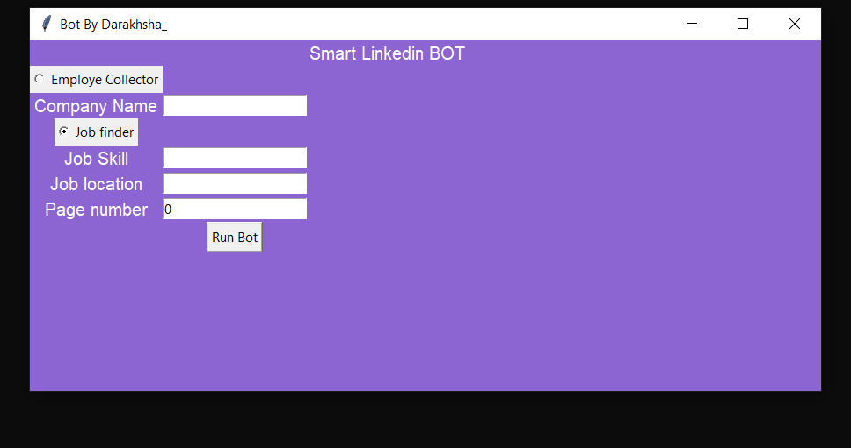

11.

SMART LINKEDIN BOT ADVANTAGES AND DISADVANTAGES

Linkedin bot advantages are:

1. Concentrate on Expanding Your Network
2. Check Out Other Company Pages
3. Job data
4. Good connection easily grab

There are some loophole are:

1. Linkedin can track automation process if highly used
2. It as just programmed bot not an artificial intelligence

CONCLUSION

SMART LINKEDIN Bot is an application for professional people and students who are working and they don’t have time to spend in linkedin and they want to make connections in linkedin for growing their network to get opportunities also they can apply for job these bot help to find the job with matching skills and location all over it replace with human who help in career related things these bot mainly save the time of people.

13.